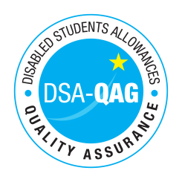
Confetti Institute of Creative Technologies - NMH Rates

Period covered - 01/04/2020 through to 31/03/2021

The table below shows NMH rates. The greyed out cells indicate that the NMH provider does not offer these services.

Note: NMH Support Rates shown per hour in the table below.
 | Standard Rate (in-person) |  |  | Distance Learning only (in-person, in-home |  |  | Remote Delivery (e.g. Facetime/Skype or similar) Only
Band 1 Support Assistants | Net | VAT | Total | Net | VAT | Total | Net | VAT | Total
Band 2 Enhanced Support Assistants
Study Assistant | 20 | N/A | 20
Examination Support Worker | 20 | N/A | 20
Note Taker | 21 | N/A | 21
Band 3 Specialist Enabling Support
Band 4 Specialist Access and Learning Facilitators
Specialist Mentor – AS | 50 | N/A | 50 |  |  |  | 50 | N/A | 50
Specialist 1:1 Study Skills Support - SpLD | 60 | N/A | 60 |  |  |  | 60 | N/A | 60
Specialist 1:1 Study Skills Support - AS | 50 | N/A | 50 |  |  |  | 50 | N/A | 50
*Please delete any rows where you do not provide this support role

