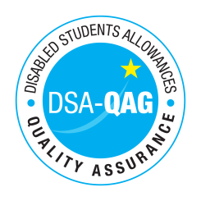
Confetti ICT - NMH Rates

Period covered – 30/09/2017 through to 30/06/2018

The table below shows NMH rates. The greyed out cells indicate that the NMH provider does not offer these services.

Note: NMH Support Rates shown per hour in the table below.
 | Standard Rate (in-person) |  |  | Distance Learning only (in-person, in-home |  |  | Remote Delivery (e.g. Facetime/Skype or similar) Only
 | Net | VAT | Total | Net | VAT | Total | Net | VAT | Total
Band 2 Enhanced Support Assistants
Study Assistant | 20 | N/A | 20
Manual note taker | 20 | N/A | 20
Examination Support Worker | 21 | N/A | 21
Band 4 Specialist Access and Learning Facilitators
Specialist Mentor – AS | 50 | N/A | 50
Specialist 1:1 Study Skills Support - SpLD | 60 | N/A | 60
Specialist 1:1 Study Skills Support - AS | 50 | N/A | 50
*Please delete any rows where you do not provide this support role

